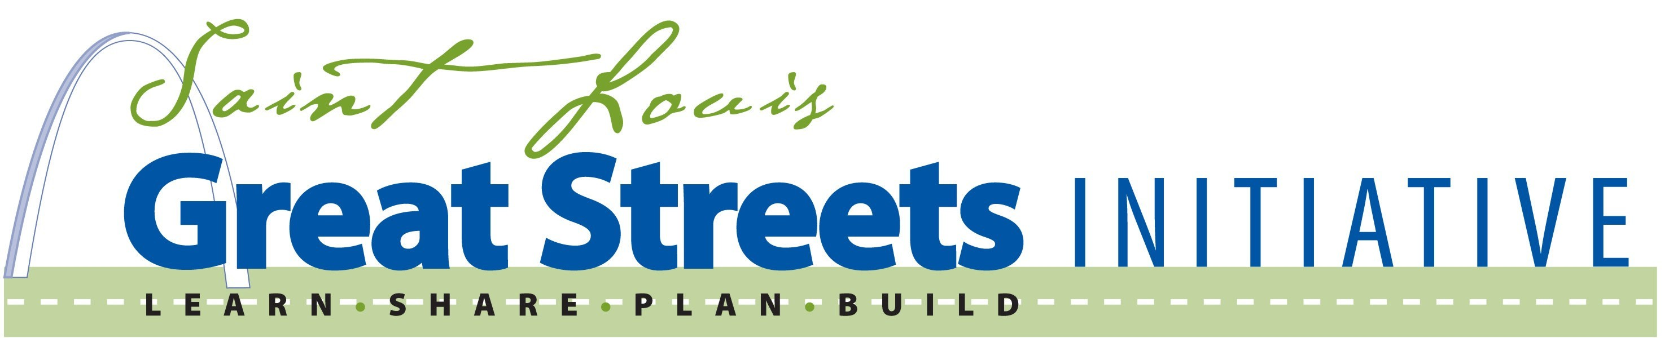

Project Application Form

Project Location

Sponsor

Supporting Contact(s) (Provide Name, Title, Organization, Phone and Email for each):
(Primary
1. Contact)

2.

3.

Owner of Road(s)

With this application cover sheet, please include the following:
1. Summary Vision for the Project (Maximum 100 words)
2. Photos of the site (up to 12 photos if available)
3. Any maps, diagrams, plans, and/or aerial photos, if available
4. Copies of or links to earlier studies, previous plans and other information that will help us understand the site and what you hope to accomplish.
5. A one-page description of the project (issues, process, outcomes) as currently conceived. Please include how each of the Great Streets principles relates to the project goals and the intended process.
6. A letter from project sponsors committing staff and logistical support for the planning effort.
7. Any letters of support from relevant agencies, officials, or community entities.

Project proposals will be reviewed and evaluated for consistency with the goals of the program and for prospects of success.

Staff will host a Teams based application workshop to walk through the process and answer any questions at 2:00 pm on November 6 (link to meeting) . Applicants may also contact staff directly for individual application assistance to review proposed project locations and draft applications. To sign up, please email GreatStreets@ewgateway.org with your desired time and format.

Applications are due at East-West Gateway Council of Governments by 3:00 PM on November 21, 2024. Applications may be emailed as pdfs to greatstreets@ewgateway.org or mailed to
Great Streets, East-West Gateway Council of Governments, One Memorial Drive, Suite 1600, St. Louis, MO 63102.

For more information, please call Paul Hubbman at East-West Gateway (314) 421-4220; (618) 274-2750, or email paul.hubbman@ewgateway.org.

